Energy-Efficient Design (p190-193)

Reducing energy consumption
- Where does most of the energy we use come from?

- Name three non-renewable energy sources.

- Name two problems associated with non-renewable energy sources.

- Greenhouse gases increase the risk of global warming and climate change. List three effects of climate change on Australia.

- Describe some ways a household can reduce their energy consumption.

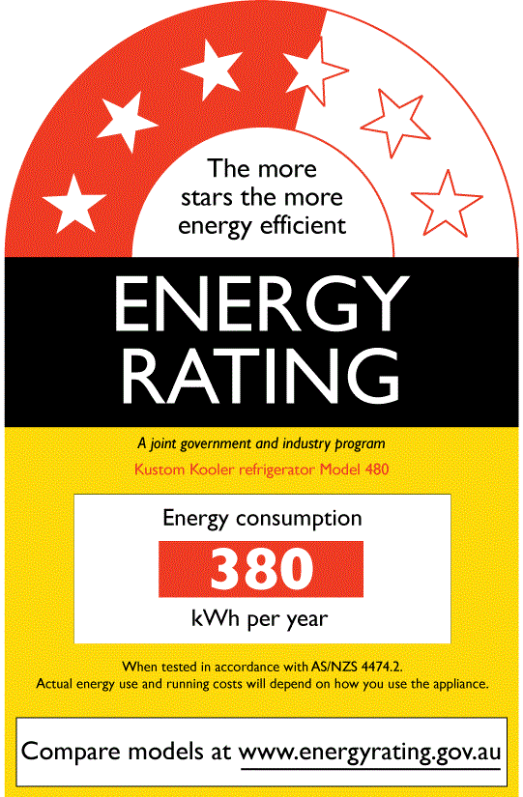
Energy Rating Labels
- What varies in household appliances?

- How do more efficient appliances help a household?

- What do the stars on an energy efficiency label show?

- There is also a number on the labels. What does this tell the customer?

Efficient Housing
- What are half the costs of a house used for?

- Where does heat flow from?

- What happens in winter?

- What happens in summer?

- What is the purpose of insulation?

- What does the National House Energy Rating Scheme do?

- List five ways the design of a house can be improved.

